Project Design Phase-I
Problem – Solution Fit Template

Date | 19 December 2025
Team Id | LTVIP2026TMIDS36439
project Name | Toycraft Tales Tableau's vision into Toy manufactures data
Maximum Marks | 2 marks

Problem – Solution Fit Template: Toycraft Tales

The Problem-Solution Fit for Toycraft Tales means identifying the specific operational pain points of toy manufacturers and proving that our Tableau-driven data analytics effectively solves them. This helps manufacturers move from "guesswork" to "data-backed decisions.”

Purpose:

- Solve Complex Manufacturing Issues: Addressing production delays and inventory imbalances in a way that aligns with the current workflow of toy factory managers.

- Faster Market Success: Increasing the adoption of new toy designs by tapping into existing customer buying patterns and seasonal trends discovered through data.

- Sharpened Communication: Using data triggers (like low stock alerts or high demand shifts) to refine marketing strategies and retail messaging for specific toy categories.

- Enhanced Trust & Touch-points: Building long-term reliability with retailers by solving "urgent or costly" problems like overstocking unpopular toys or missing out on viral toy trends.

- Optimized Target Group Strategy: Deeply understanding the current market situation to improve toy safety, pricing, and play-value for children and parents.

Templates:

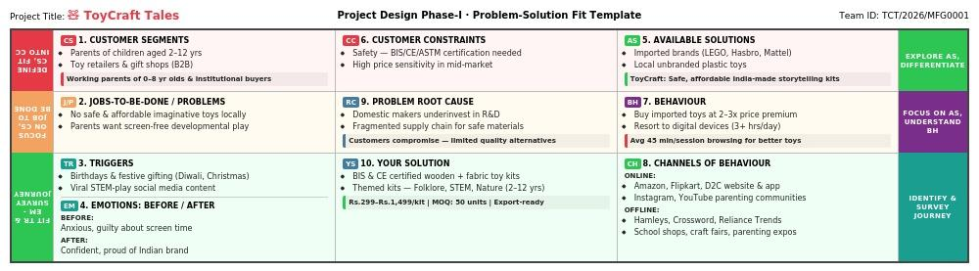

References:

1. https://www.ideahackers.network/problem-solution-fit-canvas/
2.https://medium.com/@epicantus/problem-solution-fit-canvas-aa3dd59cb4fe

